
React Notes

📌 What is React.js?
React.js is a JavaScript library for building user interfaces (UIs), mainly for Single Page Applications (SPAs). Developed by Facebook (Meta), it allows developers to create reusable UI components and efficiently manage application state using the Virtual DOM.
Key Features:
✔ Component-Based Architecture – Reusable and modular UI.
✔ Virtual DOM – Optimized rendering for better performance.
✔ Unidirectional Data Flow – Ensures predictable state management.
✔ SEO-Friendly – Works well with server-side rendering (SSR) using Next.js.

📌 History of React.js
📍 2011 – Created by Jordan Walke at Facebook to improve UI performance.
📍 2013 – Open-sourced at JSConf.
📍 2015 – React Native launched for mobile development.
📍 2016 – React Fiber project started to enhance performance.
📍 2017 – React 16 released with React Fiber.
📍 2020 – React 17 introduced gradual upgrades and event delegation.
📍 2022-2023 – React 18 added automatic batching, concurrent rendering, and transitions for a better user experience.

📌 Real-World Projects Using React.js
🚀 Facebook & Instagram – Core platforms built using React.
🚀 WhatsApp Web – Uses React + Redux for real-time chat.
🚀 Netflix – Optimized UI performance.
🚀 Airbnb – Interactive booking UI with React Fiber.
🚀 Uber & Uber Eats – Smooth navigation and dynamic UI.
🚀 Discord – Web chat app using React.
🚀 Pinterest – Handles infinite scrolling efficiently.
🚀 Reddit – Modern web interface powered by React.
🚀 Shopify – Uses React for admin dashboards & storefronts.
Why Use React?
✅ Fast rendering with Virtual DOM.
✅ Reusable components for scalable apps.
✅ Strong community & ecosystem with Next.js, Redux, and React Router.

📌 Installation of React
1.installation of bun
>npm i -g bun
>check if its install by => bun -v
2.installation of react
>bun create vite
>then follow the cmd for further installation
3.if there is an error of esbuild then run -> bun rebuild esbuild
📌 Project structure
- node_modules/ - This folder contains all the dependencies (packages) installed using npm or yarn. It is automatically created when you run npm install or yarn install. You usually don’t modify anything inside this folder.
- public/ - This folder is for static assets like images, icons, and fonts that do not get processed by Vite. It usually contains files that should be available directly in the browser.
- src/ (Source Folder) - This is where your actual project code lives.
  - app.jsx - This is the main application component. It usually contains the core structure of your React app.
  - main.jsx - This is the entry point of the app. It connects React to the index.html file and renders the App component.
  - .eslintrc.cjs - Configuration file for ESLint, a tool that helps maintain code quality by catching errors and enforcing coding standards.
  - .gitignore - A file that tells Git which files or folders to ignore when committing code (e.g., node_modules).
  - index.html - The main HTML file that loads your React app. It contains a <divid="root"></div> where your React components are injected.
  - package.json - This file contains details about your project, including dependencies, scripts, and configurations.
  - vite.config.js - The configuration file for Vite, a fast frontend build tool. It allows customization of settings like plugins and server behavior.

What is JSX?
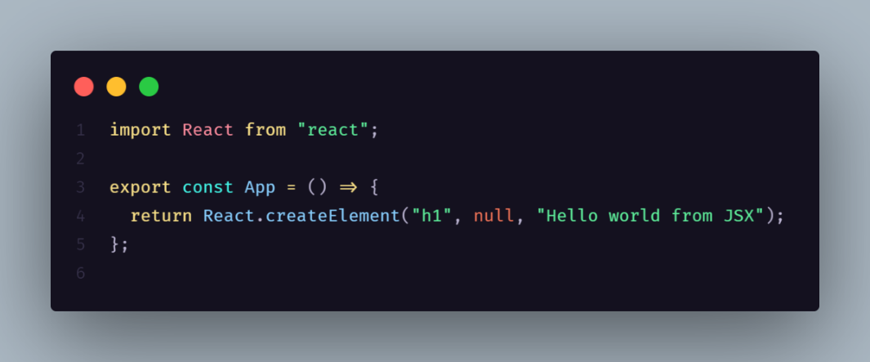
JSX stand for JAVASCRIPT XML(Extensible Markup Language) . it allows you to write HTML elements in JAVASCRIPT and place them in the DOM without any createElement() and appendChild() methods

How JSX Works
When React processes this JSX code, it converts it into JavaScript using Babel. This JavaScript code then creates real HTML elements in the browser’s DOM . which is how your web page gets displayed.
React.createElement()
It is a core function in React that is used to create React elements without JSX. When JSX is used, it gets transpiled into React.createElement calls by Babel.
The syntax is:
React.createElement(type,{props},children);
// JSX code
<type {props} >{children}</type
1. type: The type of the element (e.g., 'div', 'h1', or a React component).
2. props: An object containing properties for the element.
3. children: The content inside the component, which can be text, another element, or an array of elements.
ReactDOM : React DOM contains the arguments that are necessary to render react elements in the browser.
Syntax:
ReactDOM.render(element,containerElement);
Parameters: ReactDOM.render() takes two arguments:
1.element: The element that needs to be rendered in the DOM.
2.containerElement: Where to render in the dom.
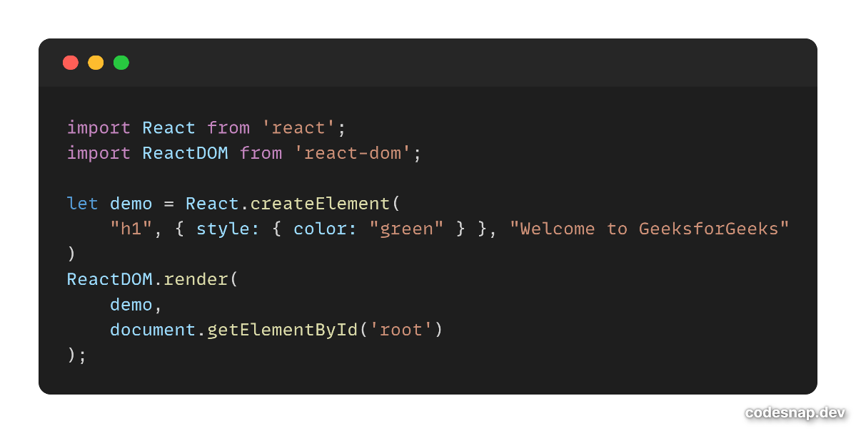
Example of code :-

React components
A component in React is like a small reusable block of UI (User Interface).
It’s just a function or class that returns JSX — the code that looks like HTML.
Think of components like Lego blocks 🧱 —
each piece builds a part of your app (button, navbar, card, etc.),
and together they form the whole webpage.
They accept inputs called props and return React elements describing the UI.
There are two primary types of React components:
1.Functional Components(modern standard)
2.Class components (older style)
1. Functional Components
Functional components are simpler and preferred for most use cases. They are JavaScript functions that return React elements. With the introduction of React Hooks, functional components can also manage state and lifecycle events.
- Stateless or Stateful: Can manage state using React Hooks.
- Simpler Syntax: Ideal for small and reusable components.
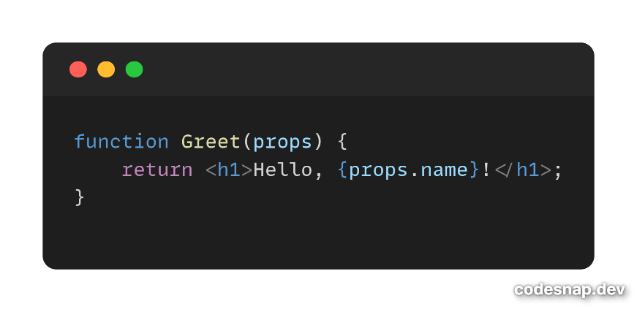
- Performance: Generally faster since they don’t require a ‘this’ keyword.
💡 Why Components Are Important
Feature | Description
🧱 Reusable | You can use the same component multiple times
🔄 Independent | Each component handles its own logic and style
🎨 Organized | Code becomes modular and easy to manage
⚡ Dynamic | Components can accept props (inputs) to change behavior

🧠 Example: Reusing a Component with Props =>

function Greeting(props) {
return <h3>Hello {props.name} 👋</h3>;
}
// Usage:
<Greeting name="Abhi" />
<Greeting name="Riya" />

What are Props (Properties)?
Props are like inputs you pass into a component — just like function parameters in JavaScript.
They help you make components dynamic and reusable.

🧩 Example:
function Welcome(props) {
return <h2>Hello {props.name} 👋</h2>;
}
export default Welcome;
👉 Use it like this:
<Welcome name="Abhi" />
<Welcome name="Riya" />
Output:
Hello Abhi 👋
Hello Riya 👋
✅ Key point:
Props are read-only — you cannot change them inside the component.

ReactJS: State vs Props

1. Introduction
In React, State and Props are two core concepts used to manage and transfer data in components.
- State → Internal data of a component (can change)
- Props → External data passed from parent to child (read-only)
Understanding both is essential for building dynamic and reusable React applications.

2. State in React
Definition
State is a built-in object that holds data inside a component and controls its behavior and rendering.
It is mutable and managed within the component itself.

Key Characteristics of State
- Local to the component
- Mutable (can be updated)
- Triggers re-render when changed
- Used for dynamic data handling
- Managed using:
  - useState() (Functional Components)
  - this.setState() (Class Components)
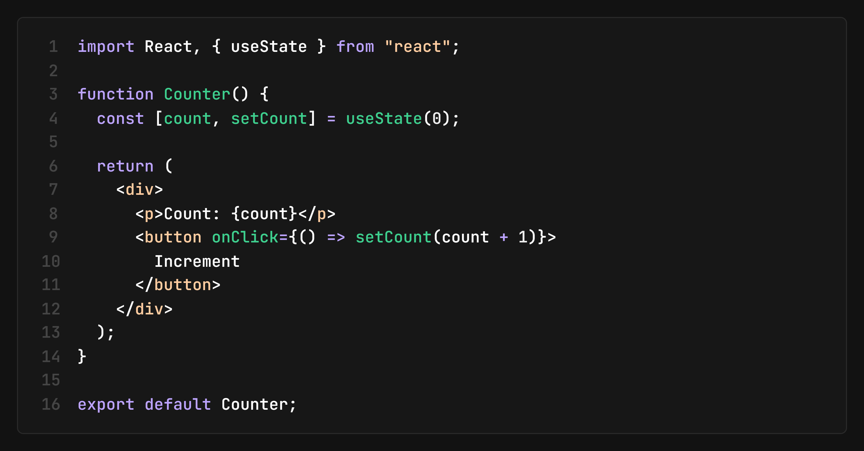

Explanation
- useState(0) → initializes state with value 0
- count → current state value
- setCount() → updates state
- Updating state causes re-render of component

Use Cases of State
- Form inputs
- Counters
- Toggle buttons
- API data handling
- Dynamic UI updates

3. Props in React
Definition
Props (Properties) are read-only inputs passed from a parent component to a child component.
They allow components to be reusable and dynamic.

Key Characteristics of Props
- Passed from parent to child
- Immutable (cannot be changed by child)
- Used for communication between components
- Makes components reusable
- Read-only in child component

Example
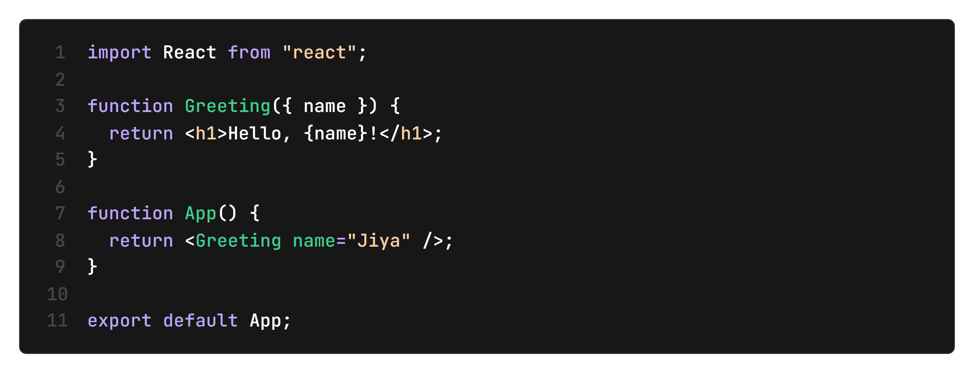

Explanation
- App (parent) passes name="Jiya"
- Greeting (child) receives props
- Displays dynamic output using props

Use Cases of Props
- Passing data between components
- UI customization
- Reusable components (buttons, cards, headers)
- Configurable components

4. Difference Between State and Props
Feature | State | Props
Definition | Internal component data | External data passed from parent
Mutability | Mutable | Immutable (read-only)
Ownership | Managed by component itself | Managed by parent component
Usage | Handles dynamic changes | Passes data to child components
Re-render | Triggers re-render on update | Child re-renders when props change
Communication | Inside component | Parent → Child
Modification | Can be updated using setState/useState | Cannot be modified by child

5. When to Use State vs Props
Use State when:
- Data changes over time
- User interaction is involved
- Component needs internal control
Examples:
- Form inputs
- Counters
- UI toggle (dark/light mode)

Use Props when:
- Data is passed from parent to child
- You want reusable components
- You want to configure a component externally
Examples:
- Passing user name
- Button text
- Card content

6. Key Interview Summary
- State = component memory (mutable)
- Props = external input (immutable)
- State is managed internally
- Props are controlled externally by parent
- Both cause re-render when updated (directly or indirectly)

React fragments
A Fragment in React is a special wrapper that allows grouping multiple elements without adding extra nodes to the DOM. This is useful when returning multiple elements inside a component without wrapping them in an unnecessary <div>.How to use it?
- Using <React.Fragment>
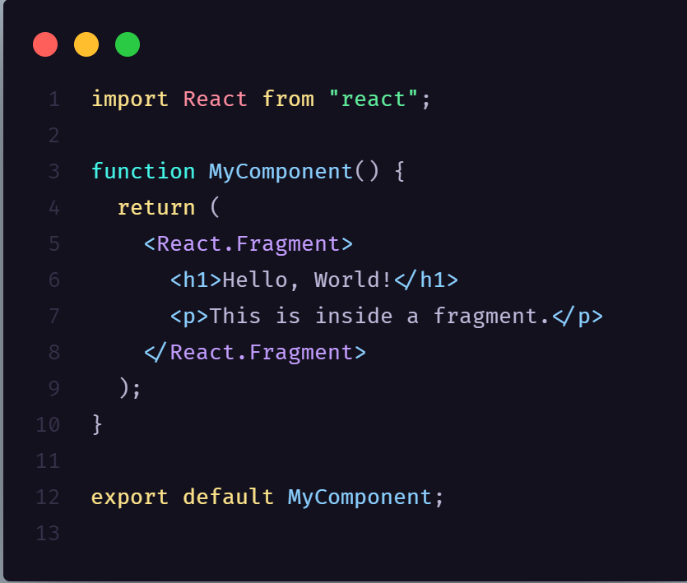
- Using shorthand <>…</> syntax {recommended}
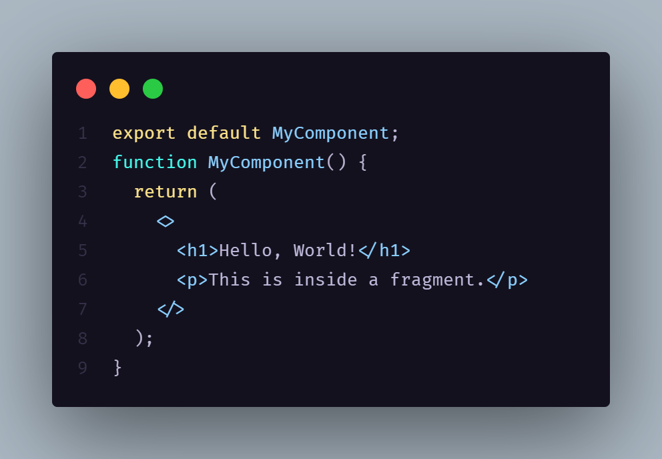

🚀 Why Use Fragments
Problem | Solution
Extra <div> messes up layout | Fragments avoid adding extra tags
Cleaner DOM structure | Fragments don’t appear in the final HTML
Useful in table rows or lists | You can return multiple <td> without a wrapper

Import and Export in React
In React.js, import and export are used to modularize the code. They allow you to split components, functions, or variables into separate files and reuse them across your application.
Exporting a component 📤 → Means sharing it so other files can use it.
Importing a component 📥 → Means bringing it into another file so you can use it there.
Types of Exports in React
In React, there are two types of exports
- Default Exports and Imports
- Named Exports and Imports
1. Default Export and Import
A default export allows you to export a single component or variable from a file. When importing a default export, you can give it any name you choose.

import React from "react";

const MyComponent = () => {
return <h1>Hello from MyComponent!</h1>;
};

export default MyComponent;

import React from "react";
import MyComponent from "./components/MyComponent";

const App = () => {
return (
<div>
<MyComponent /> {/* Using the imported component */}
</div>
);
};

export default App;

In this code
- Default Export: Exports one thing from a file (like a component).
- Default Import: Imports the default export from another file, naming it as needed.

2. Named Export and Import
Named exports allow you to export multiple components or variables from a single file. When importing a named export, you must use the exact name of the exported entity.
export const MyComponent = () => {
return <h1>Hello from MyComponent!</h1>;
};

export const AnotherComponent = () => {
return <h1>Hello from AnotherComponent!</h1>;
};

import { MyComponent, AnotherComponent } from "./components/component.js";

const App = () => {
return (
<div>
<MyComponent />
<AnotherComponent />
</div>
);
};

export default App;

This code demonstrates Named Export and Import in React:
- Exporting Components: MyComponent and AnotherComponent are exported individually using export.
- Named Import: They are imported using {} from components.js, meaning their names must match exactly.
- Usage in App Component: Both components are used inside App to render them.
- Combining Default and Named Exports in React
You can export both a default component and named components from the same file. This allows flexibility in importing.
Same as but in App.jsx
Syntax is import {//for named component},//for default component from “./src”
🧠 Default vs Named Export (Quick Table)
Feature | Default Export | Named Export
Number of exports | Only one per file | Many allowed
Import syntax | import X from './file' | import { X } from './file'
Can rename? | ✅ Yes | ✅ Yes (with as)
Example | export default Hello | export function greet() {}

💡 Dynamic Values in JSX
To use dynamic (changing) data inside JSX,
you wrap any JavaScript expression inside curly braces { }.

⚛️ What is JSX?
JSX (JavaScript XML) is a special syntax that lets you write HTML + JS together inside React.
It looks like HTML, but it’s actually JavaScript behind the scenes.

🧩 1️⃣ Example: Variables inside JSX
function Hello() {
const name = "Abhi";
const age = 21;
return (
<h2>
Hello {name}, you are {age} years old 👋
</h2>
);
}
export default Hello;
✅ Output:
Hello Abhi, you are 21 years old 👋
👉 Anything inside {} runs like normal JavaScript.
🧠 Quick Rule

Type | Example | JSX Allowed?
Expression | {name}, {1 + 2}, {isOnline ? "Yes" : "No"} | ✅ Yes
Statement | {if (...)}, {for (...)}, {while (...)} | ❌ No

⚛️ What is Conditional Rendering?

Conditional rendering means —
👉 showing different UI based on some condition (true/false).
In React, you can’t use normal if statements inside JSX {} —
but you can use expressions like:
- Ternary operator ? :
- Logical AND &&

const GreetUser = () => {
const isLoggedIn = true;
return (
<h1>{isLoggedIn ? "Welcome Back, Abhi!" : "Please Log In"}</h1>
);
}
export default GreetUser;

🧩 P-1: React does not render false, null, undefined, or NaN
✅ Code Example
import React from "react";

const RenderTest = () => {
const val1 = false;
const val2 = null;
const val3 = undefined;
const val4 = NaN;
const val5 = 0;
const val6 = "";

return (
<div style={{ fontFamily: "sans-serif", padding: "20px" }}>
<h2>React Rendering Test</h2>

<p>1️⃣ false → {val1}</p>
<p>2️⃣ null → {val2}</p>
<p>3️⃣ undefined → {val3}</p>
<p>4️⃣ NaN → {val4}</p>
<p>5️⃣ 0 → {val5}</p>
<p>6️⃣ empty string → "{val6}"</p>
</div>
);
};

export default RenderTest;

🧠 What Happens
When you open this component, you’ll see:
React Rendering Test
1️⃣ false →
2️⃣ null →
3️⃣ undefined →
4️⃣ NaN → NaN
5️⃣ 0 → 0
6️⃣ empty string → ""

⚙️ Why This Happens
Value | Displayed in DOM? | Reason
false | ❌ Not rendered | React ignores false, null, undefined when used directly in JSX
null | ❌ Not rendered | Means “nothing” — React skips rendering
undefined | ❌ Not rendered | Treated same as null
NaN | ✅ Shows "NaN" | Because NaN is a string when converted to text
0 | ✅ Shows "0" | 0 is a valid number — React renders it
"" | ✅ Shows empty space | Empty string is valid text — React renders it but looks blank

🔍 In Short
React ignores:
false, null, undefined
React renders:
0, "", NaN, true (ignored but not rendered as text)

⚡ Pro Tip — Conditional Rendering Trap
If you do something like:
{isOnline && <p>Online</p>}
and isOnline is false, React renders nothing — not even "false" text.
That’s why this trick works for conditionals.
But if you write:
{0 && <p>Online</p>}
It shows 0 — because 0 is falsy in JS but still renders visibly in JSX.

Looping in react
Basic of map()
The map() method is an ES5 feature that creates a new array by applying a function to each element of the original array. It skips empty elements and does not modify the original array.

const a = [1, 2, 3, 4];
// Use map to create a new array with elements doubled
const b = a.map(x => x * 2);
console.log(b);
output => [2,4,6,8]

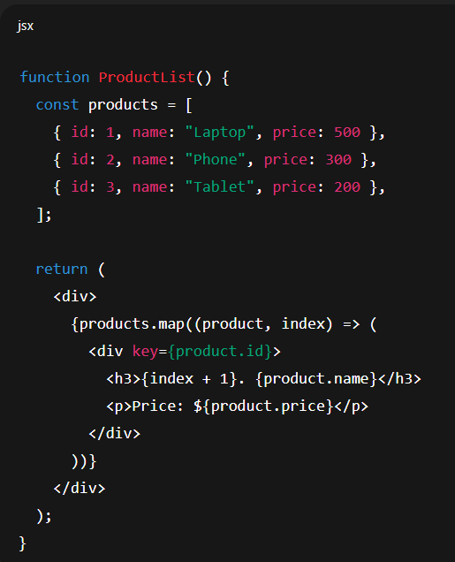
Syntax
arr.map((element, index, array) => {
// Return a new value for the new array
})
Parameters:
- element → current value of the array (required).
- index → position of the element (optional).
- array → the original array (optional).
Return value:
- A new array containing whatever your callback function returns for each element.

React doesn’t have its own for or while syntax for rendering UI —
instead, we use JavaScript array methods, most commonly .map().

✅ 1️⃣ Basic Example — using .map()
import React from "react";

const LoopingExample = () => {
const fruits = ["🍎 Apple", "🍌 Banana", "🍇 Grapes", "🍊 Orange"];

return (
<div style={{ fontFamily: "sans-serif", padding: "20px" }}>
<h2>🍉 Fruit List</h2>

<ul>
{fruits.map((fruit, index) => (
<li key={index}>{fruit}</li>
))}
</ul>
</div>
);
};

export default LoopingExample;

🧠 What Happens
- React runs .map() on the fruits array.
- For each item, it returns an <li> element.
- The key helps React efficiently update the DOM (must be unique per list).

⚙️ Why .map() is used
Because JSX needs an array of React elements to render multiple items.
If you do this ⛔:
for (let i = 0; i < fruits.length; i++) {
<li>{fruits[i]}</li>;
}
React will show nothing — for loops don’t return a new array of elements.

✅ 2️⃣ Rendering an Array of Objects
const students = [
{ id: 1, name: "Abhi", age: 20 },
{ id: 2, name: "Riya", age: 21 },
{ id: 3, name: "Sam", age: 19 },
];

return (
<div>
<h2>🎓 Student List</h2>
<ul>
{students.map((student) => (
<li key={student.id}>
{student.name} — Age: {student.age}
</li>
))}
</ul>
</div>
);

✅ 3️⃣ Conditional + Loop Together
You can combine .map() with conditionals:
<ul>
{students
.filter((student) => student.age >= 20)
.map((student) => (
<li key={student.id}>{student.name} (Age {student.age})</li>
))}
</ul>
→ This first filters and then loops, showing only students age ≥ 20.

✅ 4️⃣ Loop with Index or Custom JSX
<ul>
{fruits.map((fruit, i) => (
<li key={i}>
#{i + 1} — {fruit.toUpperCase()}
</li>
))}
</ul>

⚠️ Important Notes
Concept | Meaning
key | Must be unique per item; helps React track changes
.map() | Must return JSX elements
.forEach() | ❌ Does not return anything — not used for rendering
filter(), sort(), slice() | ✅ Can be chained with .map()

✅ Pro Tip — Inline Return
When your map() callback has only one line, you can skip {} and return:
{fruits.map((f, i) => <li key={i}>{f}</li>)}

🧩 Takeaway
🧠 Use .map() to render lists in React.
Always add a unique key and make sure your function returns JSX.

Event Handling in React
Just like in JavaScript, you can respond to user actions (like clicks, typing, hover, etc.) —
but in React, events are handled using camelCase and passed as functions.
✅ Example: Button Click
function ClickDemo() {
const handleClick = () => {
alert("Button clicked!");
};

return <button onClick={handleClick}>Click Me</button>;
}
🧠 Notes:
- onClick instead of onclick
- Pass the function reference → not handleClick() (no parentheses)
- React automatically wraps events in its SyntheticEvent system

Inline Event Handling
You can write the function directly inside the JSX (not best practice but okay for small cases):
<button onClick={() => alert("Inline Click!")}>Click Inline</button>
✅ Quick
⚠️ Avoid for complex logic (creates new function every render)

Event Handling + Props
Combine both to send event functions from parent to child 👇
(very common in React apps)
const Parent = () => {
const handleMessage = (msg) => alert(msg);

return <Child onSend={handleMessage} />;
};

const Child = ({ onSend }) => (
<button onClick={() => onSend("Hello from Child!")}>Send Message</button>
);
🧠 Child triggers parent function → communication upward.

Passing event handling by Props
🔹 What It Means
In React, passing event handling by props means:
You create an event handler (like handleClick) in a parent component and pass it down to a child component using props.
Then, the child component can call that function when an event (like a click) happens.
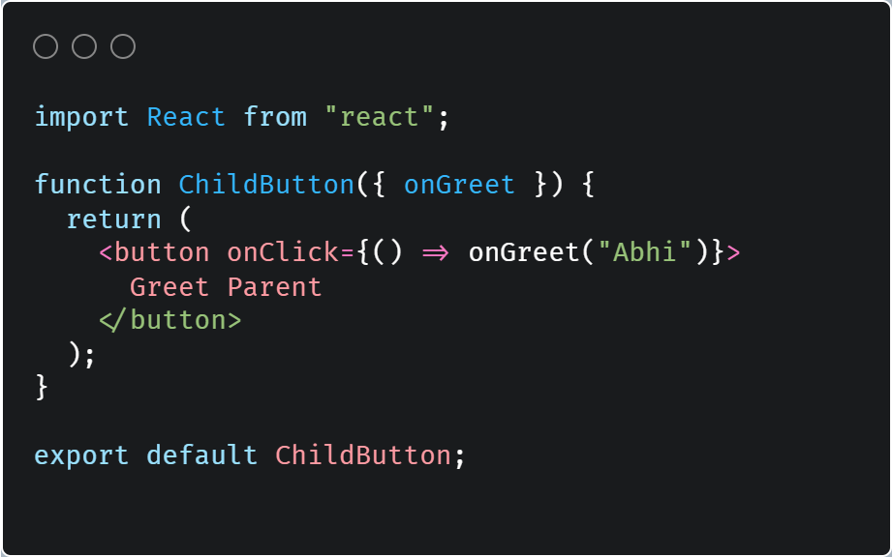
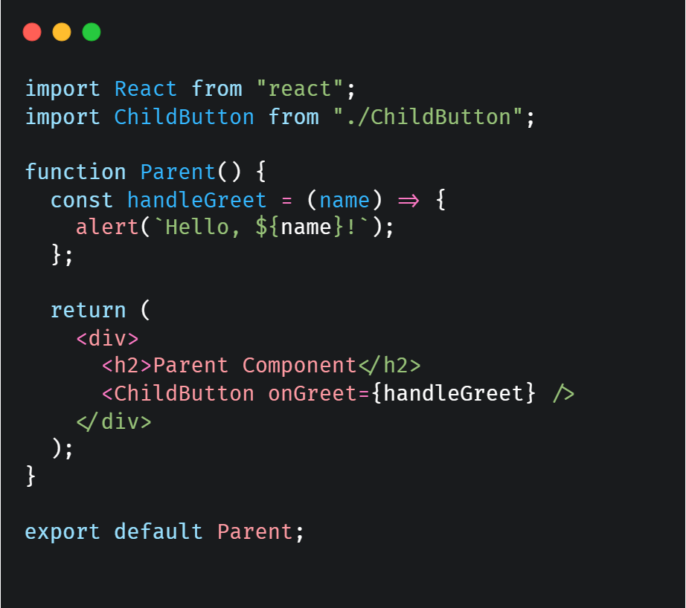
Figure 1child
Figure 2- Parent

Event Propagation
🔹 What Is Event Propagation?
Event propagation means how an event moves through the DOM tree when it occurs.
When you click a button inside a div, React (and the browser) doesn’t just handle the event at the button — it travels through different phases.
3 Phases of Event Propagation
- Capturing Phase (Top → Target)
The event travels from the root element down to the target element.
→ In React, this is handled using onClickCapture.
- Target Phase
The event reaches the exact element you interacted with.
- Bubbling Phase (Target → Top)
The event then bubbles up from the target element back to the top (document).
→ In React, this is handled using onClick (default).
Default in React: Bubbling Phase
By default, React handles events during the bubbling phase — meaning:

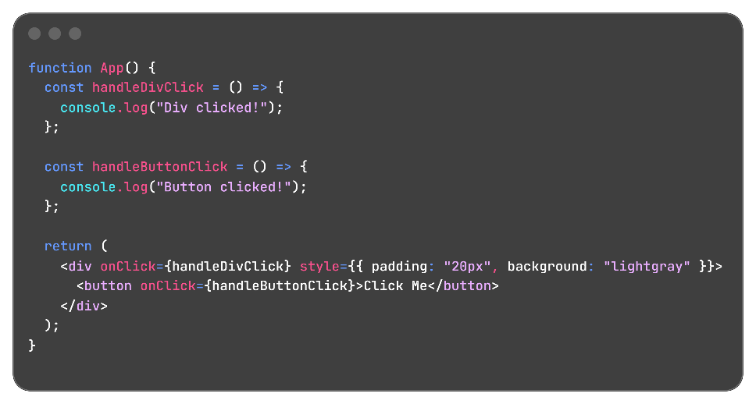
When you click a child, the event bubbles up to its parent unless you stop it.
Key Points
- React handles events in the bubbling phase by default.
- You can stop the event from moving up using
👉 event.stopPropagation().
- You can listen during the capturing phase using
👉 onClickCapture.

States In react
State is like a component’s memory — it stores data that can change over time and affects what’s displayed on the screen.
Whenever state changes, React re-renders that part of the UI automatically.

🔹 Example in One Line
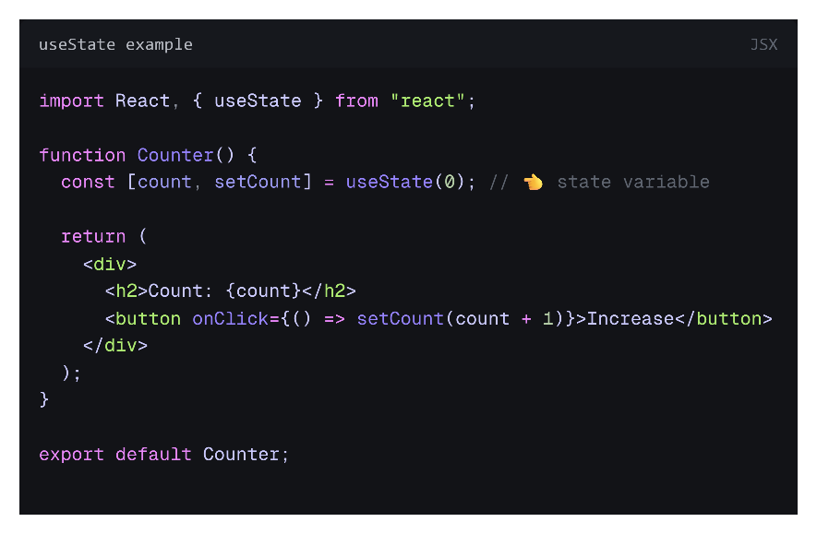
“State = data that changes + re-renders the component.”
🧠 What Happens
- useState(0) → creates a state variable count and a function setCount to update it.
- Initially, count = 0.
- When button is clicked, setCount(count + 1) changes the state.
- React re-renders the component with the new value.
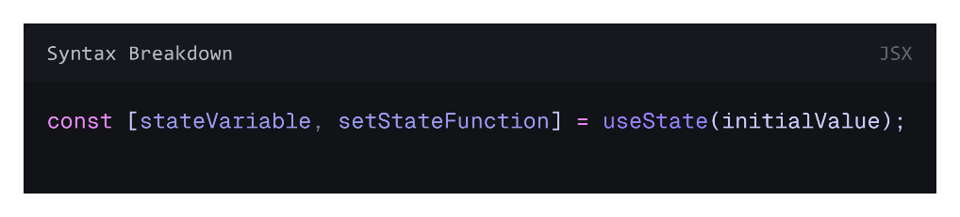
Part | Description
stateVariable | The actual data/value
setStateFunction | Function to update the state
useState(initialValue) | React Hook to define state inside a functional component

When to Use State
- When data changes over time
- When UI should update automatically
- For interactive elements: forms, counters, modals, toggles, etc.

🔹 State vs Props
Feature | State | Props
Ownership | Owned by component itself | Passed from parent
Changeable? | ✅ Yes (mutable) | ❌ No (read-only)
Who updates it? | Component itself | Parent component
Used for | Dynamic data | Data communication

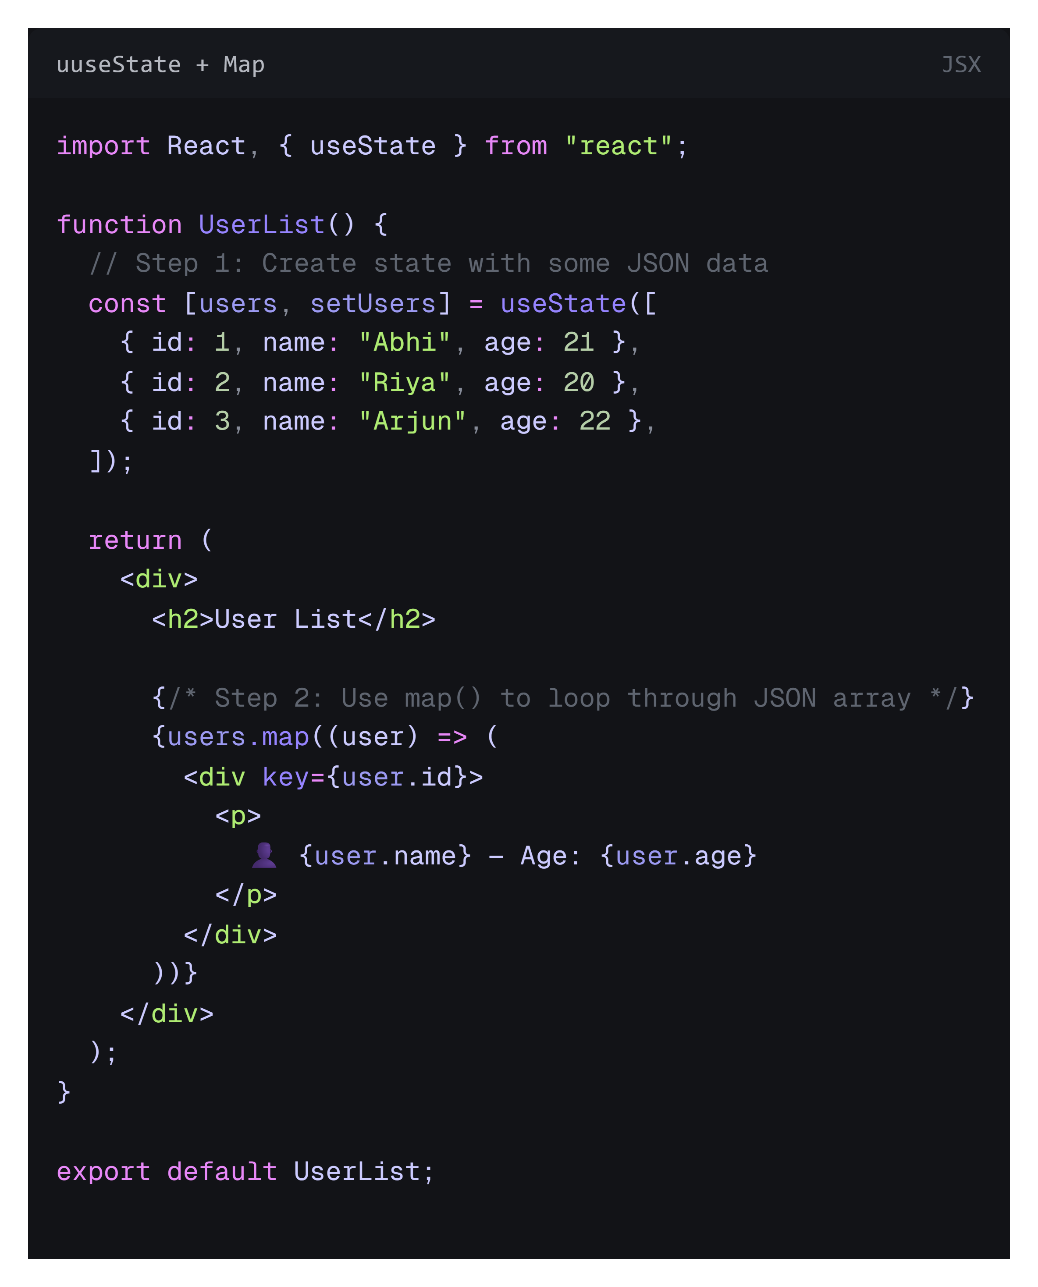
challenge -1 use of map and usestate to render data

Derived States
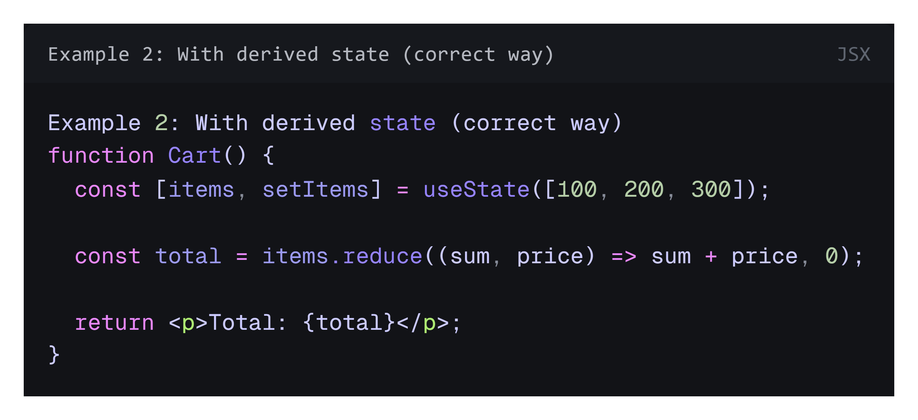
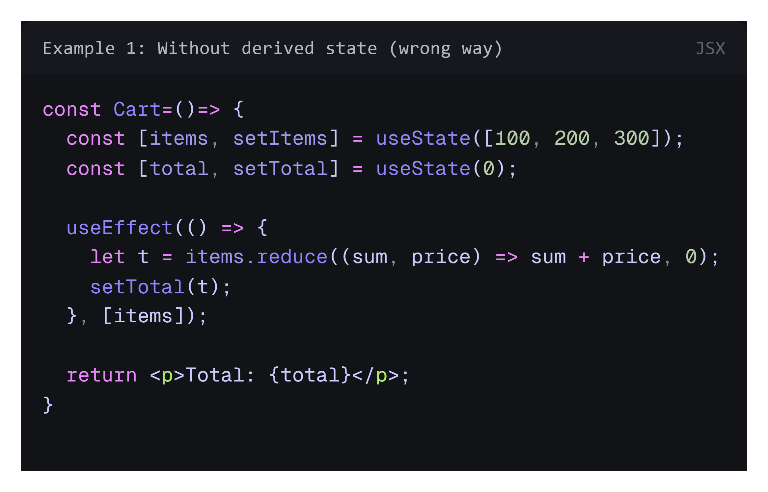
Derived state means:
➡️ a piece of state that can be calculated from existing state or props.
It’s not directly stored — instead, it’s derived from other data.
🧩 Why use Derived State?
Because it:
- Prevents bugs — avoids data getting out of sync.
(If you forget to update total, it will show wrong value.)
- Reduces complexity — less state → simpler logic.
- Improves performance — React doesn’t re-render extra state unnecessarily.

⚠️ What if you don’t use derived state?
If you store derived data as separate state:
- You’ll risk inconsistent UI (e.g. items change but total doesn’t).
- You’ll write more code to keep both in sync.
- You’ll confuse your app logic — React recommends minimal state.

🧮 In short:
Concept | Description
State | Data that changes over time (user input, API data)
Derived State | Computed from state or props (no need to store)
If you don’t use it properly | You’ll duplicate data and create sync issues

Lifting state In react

Keys In React

React JS hook Rules
1. Only Call Hooks at the Top Level
- ✅ Do: Call hooks at the top level of your function.
- ❌ Don’t: Call hooks inside loops, conditions, or nested functions.
Why?
React relies on the order of hook calls. If hooks are used conditionally, their order can change between renders, causing bugs.
// ✅ Correct
function MyComponent() {
const [count, setCount] = useState(0);
}

// ❌ Incorrect
function MyComponent() {
if (someCondition) {
const [count, setCount] = useState(0); // ❌ Wrong
}
}

2. Only Call Hooks from React Functions
- ✅ Do: Use hooks inside functional components or custom hooks.
- ❌ Don’t: Use hooks in regular JavaScript functions, classes, or outside components.
// ✅ Correct
function MyComponent() {
const [user, setUser] = useState(null);
}

// ✅ Correct (Custom Hook)
function useCustomHook() {
const [value, setValue] = useState(0);
return value;
}

// ❌ Incorrect
function randomFunction() {
const [x, setX] = useState(0); // ❌ Hooks only work in React components or custom hooks
}

useState() in react JS

useRef() in react JS

useID() in react JS

prop drilling in react JS
1. Definition
Prop drilling is the process of passing data from a top-level (parent) component to deeply nested child components through multiple intermediate components that don’t actually use the data.
In simple terms:
You pass props through components that don’t need them, just to reach a child that does.

2. Why it happens
React data flows one way (top → bottom). So if a deeply nested component needs data, it must be passed step-by-step through every level.

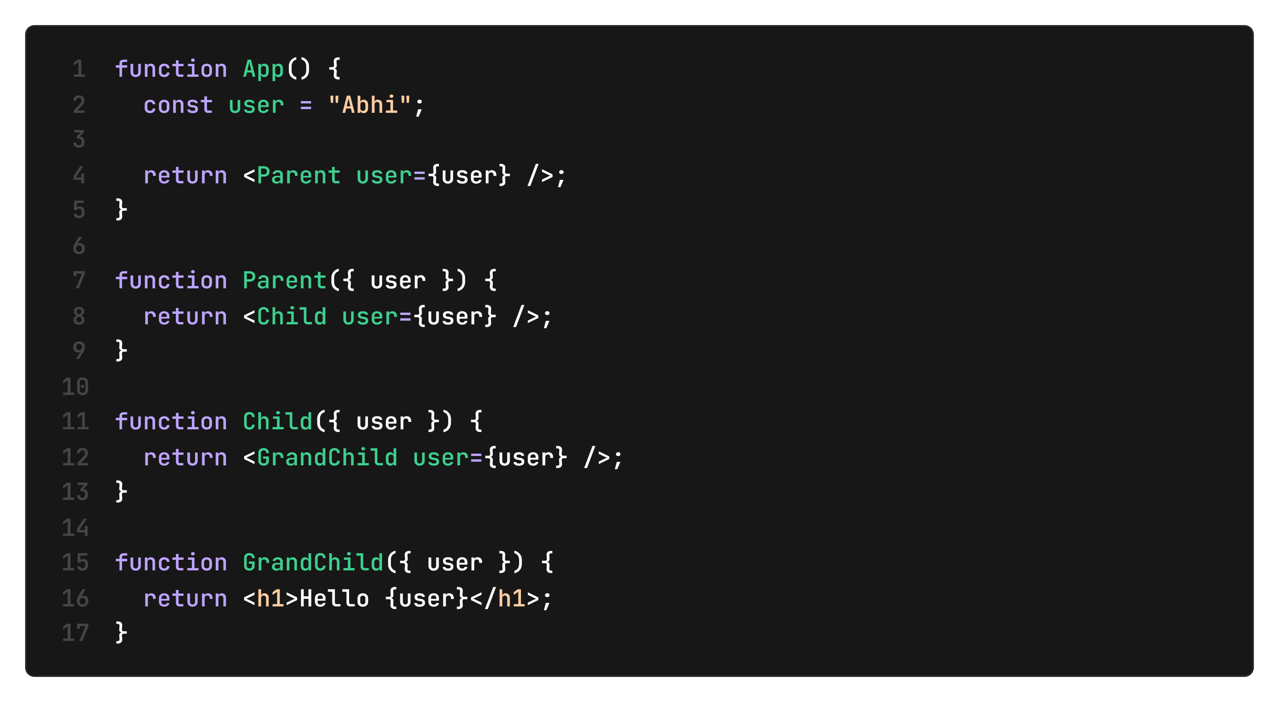
3. Example of Prop Drilling
4. Problem in this code
- Parent and Child don’t use user
- They only pass it forward
- Only GrandChild actually needs it
This is prop drilling.

5. Why Prop Drilling is a Problem
❌ Unnecessary code passing
Intermediate components become cluttered.
❌ Hard to maintain
If structure changes, you must update multiple components.
❌ Poor scalability
Deep component trees become messy.
❌ Reduced readability
It becomes hard to track where data is actually used.

6. Real-world analogy
Imagine:
- You give a message to Person A
- Person A passes it to Person B
- Person B passes it to Person C
- Only Person C needed the message
Everyone in between is just forwarding it → this is prop drilling.

7. How to avoid Prop Drilling
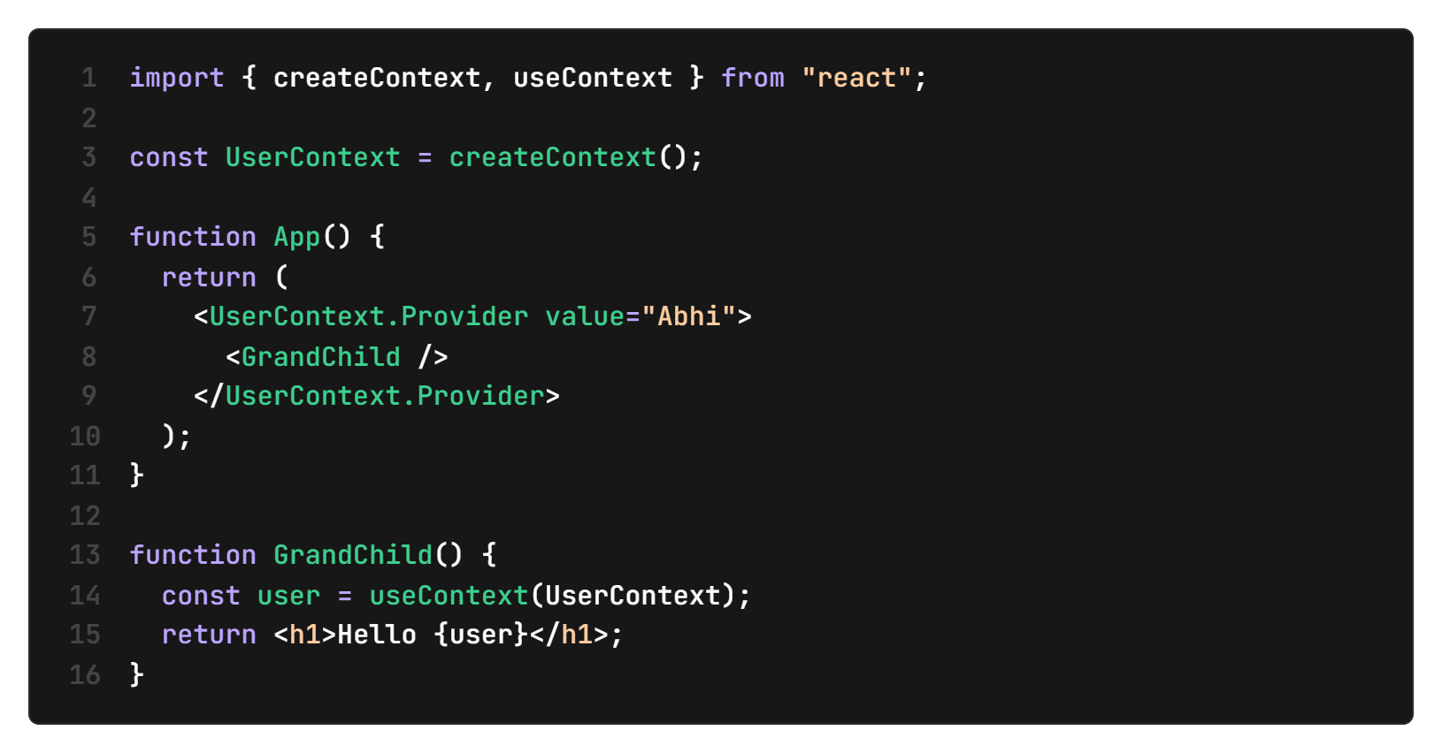
✅ 1. React Context API (Best solution)

✔ No need to pass props manually
✔ Cleaner and scalable

✅ 2. State Management Libraries
- Redux
- Zustand
- Recoil
Used in large applications.

✅ 3. Component Restructuring
Move state closer to where it is needed.

8. Key Interview Definition
Prop drilling is a situation in React where data is passed through multiple intermediate components that do not use the data, only to reach a deeply nested component that requires it.

Context API and Provider Hook

Custom hook

useReduce hook

